

**Project Report**

**Independency on choosing subject for Bangladeshi student**

**Prepare for**

**Dr. Razib Hayat Kahn**

**Independent University, Bangladesh**

**AUTUMN 2023, CIS - 101, Sec: 11**

**Prepared by**

**Joy Debnath**

**ID: 2111217**

**08 December 2023**

|  |  |  |
| --- | --- | --- |
| **Serial No.** | **List of Topic** | **Page No.** |
| **01** | **Cover Page** | **01** |
| **02** | **List of Content** | **02** |
| **03** | **Introduction** | **03** |
| **04** | **Research Question** | **03-04** |
| **05** | **Research Objective** | **04-05** |
| **06** | **Research Method** | **05-06** |
| **07** | **Description** | **06** |
| **08** | **Literature Review** | **07** |
| **09** | **Contribution** | **07-08** |
| **10** | **Data Presentation** | **08-12** |
| **11** | **Result Discussion** | **12-13** |
| **12** | **Learning Outcome** | **13** |
| **13** | **Reference** | **14** |

**Introduction: “**Education is backbone of a nation” since our childhood we are memorizing this universal statement. This statement is capable enough to be self-defined. So, its confirmed that to create a powerful nation the government should make all the citizen literate. Bangladesh being a developing country we along with all the country member should eradicate the curse of illiteracy from this country. However, we facing many problems with the term illiteracy. On a random research it has been pointed out that Bangladeshi student don’t like the education system and they don’t get the privilege to choose their sector of studies by their own (QUORA, 2022)



We strongly believe that if anyone wants to learn something he/she has to enjoy studying this particular project, and this only possible when he/she get the chance to choose their field of study by their own. However, in our cultural is has been widely practiced that our guardian selects everything for us sometimes even without knowing our desires, even though when it comes to choosing subject or field of studies the practice is remain same in most cases. That is the first steps makes a breakdown on the studies of a major group of students.

**Research Question:** Here to support my project work, I’ve made a survey among some current student about their independency on choosing subject for their study. I have had a lot fun doing this work. I’ve created bunch of questions that are relevant to my project and helped me to collect data that are required for my project. This section really helped me to gather information which support my project work.

My survey questions are

* What is your current study label?
* Do you enjoy your study?
* Is your study helping you to move towards your goal?
* Did you choose the subject of your studying?
* Why are you studying on your current subject?
* Have you find any interest in your childhood studying on that subject?
* If you get another chance will you choose this subject again?
* Is your subject helping you to meet your carrier objectives?
* Will you suggest anyone to study on your subject?

I’ve recorded people’s response on my survey question. Where I collect people’s answer on my questions and that motivates me to work on this project.



**Research Objectives**: My research objectives were to knew what percentage of people had the privilege to choose their subject for themselves. Moreover, how much they are enjoying their studies. There’s a saying that “Smart work is more efficient than hard work, in case of gaining success on anything. Because, we all know that, no one can be successful on their work if they don’t enjoy what they are doing. So, it’s very important to enjoy your work. Studies makes a person capable to gaining knowledge, work efficiency, work accuracy, life-management, and most importantly study convert a person into human, it magnifies the humanity on a person’s mind and activities.



If you are not enjoying what you studying that will turn you off, and all of that will just be a waste of time. On the contrary, if you enjoying whatever you studying, this will turn you on and help you to move forward with your studies. You’ll never be bored if you enjoying what you studying. So in conclution, my research object were to know how much people enjoying their studies and how much its helping them towards their carrier objectives.

**Research Method:** To support my project work, I have to rely on various method to collect my required information and data.

The best method that helped me to collecet information is gooogle form. That was very easy and fun to use. All I just had to do is to send my survey form link to people though facebook, instagram and many more social media. People jjust answered my querys through the google form and which in saved on my google drive. I can see people answers with many options like manual answer list, pie-chart, tally-chart.



I also read some newspaper like “The Daily Star”, “Bangladesh Protidin”, “Prothom Alo” and many more. These newspaper helped me to collecet some previous data that helped me to compare with my analysis.

I also talked with some of my friend, their information also helped me to go on with my project work.

All the method I have mention abore are really helpful to collect any sort of information. I did used them in many work of mine. Even apart from all these mathod I also look for informations on youtube.

**Description:** Students are the future ruler of a nation. Every student must play an important role for their country in a various way and different stages of their life-times. Sometimes they had to take decisions that are important for their family, society, and eventually for their country, that the reason they should be highly educated and knowledge-full. To become well educated we must have to choose the field of studies according to our interest and available circumstances.



However, in our cultural we are practicing the ritual that children don’t know much about themselves and they cannot take any corrective decision from their own. That is the reason why we couldn’t get the privilege of choosing our field of studies, and sometimes we can cooperate with the unwanted subject and sometimes we cannot. Even from the institution point of view students aren’t happy with the curricular activities of their educational institute. In the rural areas there aren’t equally available subjects of studies in educational institution which results dissatisfaction among students with their studies (star, 2023)

**Literature Review:** in my point of view, I do believe that, when it comes to independence in choosing subject for Bangladeshi students, it’s an important aspect to consider. In Bangladesh, student often face limitations in selecting their subject due to social and parental expectations. The education system tends to prioritize certain subject over others, leading to limited options for students. However, there has been a growing recognition of the need to promote independence in subject selection. Efforts are being made to encourage student to explore their interest and passion. Some schools and institutions are offering a wider range of subjects, giving students more flexibility in choosing what they want to study.

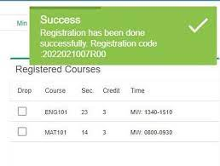

Moreover, the availability of carrier counseling and guidance service has also played a role in empowering students to make informed decision about their subjects. I’m also privilege that my institution named Independent University, Bangladesh also offering this carrier counseling service, which is really helpful to choose a better carrier. Even these services provide information about different carrier paths and help students align their interests with their academic choices. Overall, while there may still be some challenges, the trend towards promoting independence in subject selection is gaining momentum in Bangladesh. It’s exciting to see students having more opportunities to pursue their passion and shape their educational journeys.

**Contribution:** One important aspect to consider is the impact of independent subject selection on student motivation and engagement. When students have the freedom to choose subjects they are genuinely interested in, it can greatly enhance their enthusiasm for learning. They are more likely to be actively engaged in their studies and perform better academically. Additionally, independent subject selection allows students to explore their strengths and passions, which can lead to better career prospects in the future. When students are able to pursue subjects that align with their interests, they are more likely to excel in those areas and find fulfilling careers in the long run. It's also worth mentioning the role of parental support and societal mindset in fostering independence in subject selection. Encouraging parents and society as a whole to be more open-minded and supportive of student’s choices can have a positive impact on student’s ability to freely choose their subjects. Lastly, it’s important to highlight the need for continuous efforts in improving the education system to provide a wider range of subject options and guidance services. This will empower students to make informed decisions and explore a variety of subjects that cater to their individual interests and aspirations.

**Data Presentations:** As I have mentioned before that I’ve collected data from people to support my report work, here I’m sharing whatever they’ve responded to my survey questions.

Here my first question about my audience’s name. and I’m skipping that one while presenting here.

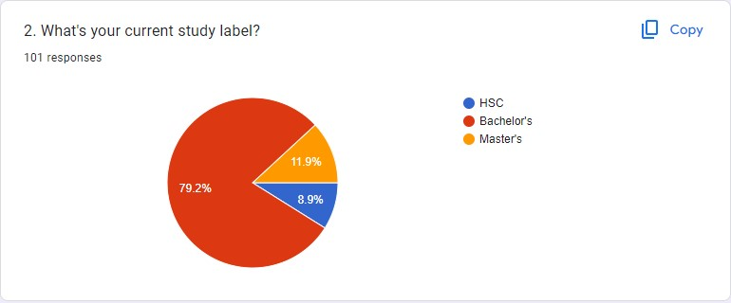

My second question’s answer showing my audiences study label, in which class they are studying in (with MCQ type)

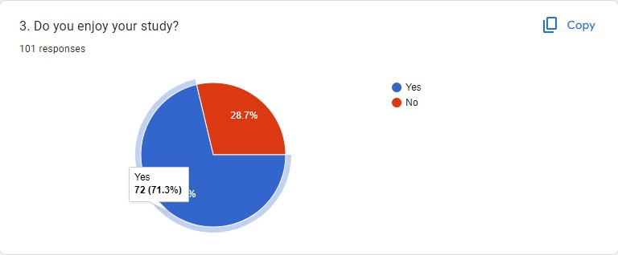

The next image is showing the result of my third question, weather my audiences are enjoying their study or not. Here I’ve got that 71.3% of my students are enjoying their study. However shockingly 28.7% students are not enjoying their study very well, among them a major number of responses are comes from bachelor student who isn’t enjoying their study which is surprising and harmful to a nation at the same time. Because they are living on the important time of their student’s life.

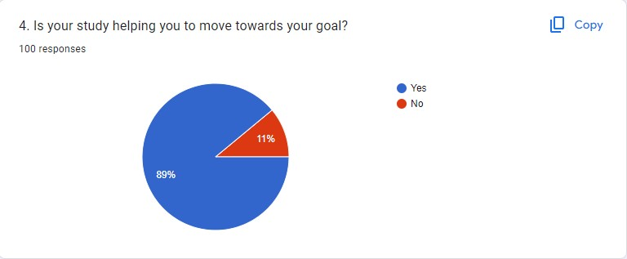

On my fourth question I asked them are their study supporting to their carrier objectives or not. Where 89% of my audience find in relevant where 11% didn’t found any reasons of relevance with their carrier objectives.

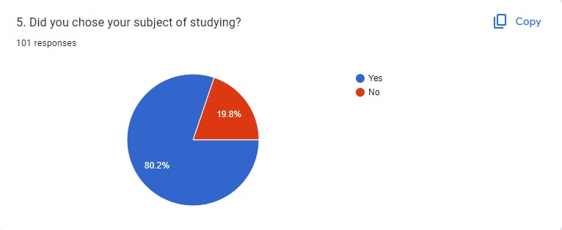

The fifth question, I actually asked because once I also couldn’t choose my subject by my own. However, now in even more satisfy then my expected subject. And among my audience there are 19.8% of people who’ve also faced the same as mine. But I’m not sure currently they are feeling the same as me or not. However, I’m very happy with this response that 80.2% of my audience had that privilege to choose their subject by their own.

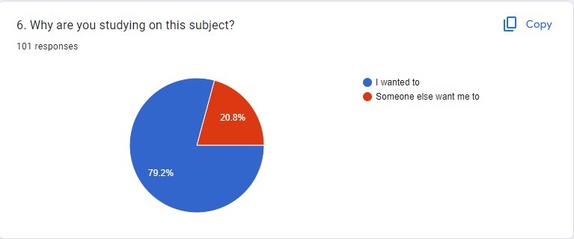

Sixth question was to support my previous question.

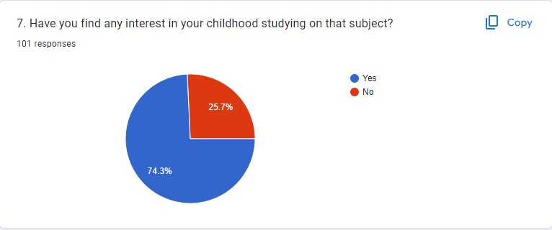

On my seventh question, I asked to my audience if they have any passion on the subject where they are studying currently. Where 74.3% responded positive and 25.7% gave a negative answer.

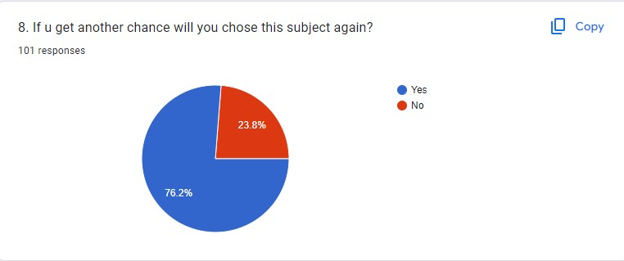

I was so optimistic on my eighth question to get 100% positive answer. Because I personally believe that if you still wanted to change your subject on your bachelor or masters label that’s really a disgraceful.

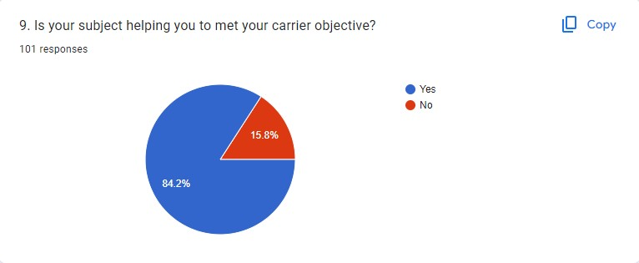

On my ninth question, I get to know that, among my audiences 84.2% believe that their study is helping them to meet their carrier objectives and 15.8% didn’t find it useful.

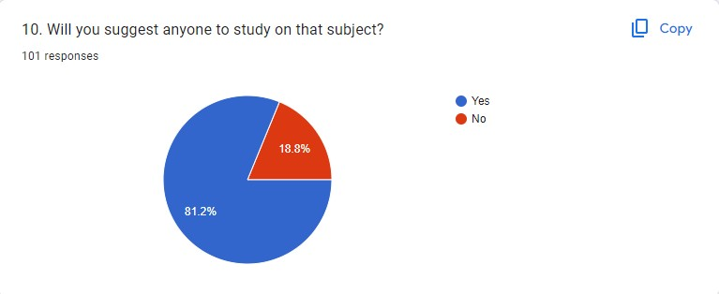

On my last (tenth) question I asked for a recommendation from my audience about their subject to other. Where 81.2% strongly recommend their subject to others and 18.8% aren’t willing to recommend to their followings.

**Result Discussion:** From the outcomes of my survey questions I come up with a bunch of positive response foe all my survey question. Which is good in a sense, but in some situation the percentage of negative response makes me worried. I do believe that, consistency makes one perfect and helps to acquire brilliance and on a task. So if a student maintains his/her consistence on his/her studies they will gain success even if they didn’t like their subject much. However, in one of my survey question I asked from did they like their study where around 1\5th of the student responded negative. Overall, throughout my survey is gives me a good learning and teach me to gain someone’s response in a good way and use it to my project work. And I can say based on my survey that, education system of Bangladesh has gone so far on the competition of better education system throughout the world.

**Learning Outcome:** I have picked that topic for my project work, because it was relevant to me somehow. And I wasted to knew others thought on the same topic are they faced the same as mine or not. And the best part is I’m very glad to know that people becoming more attracted to their studies day by day if I compare my survey outcome with the previous analyzed data. On the other hand, nowadays we are witnessing of the concept brain drain in our country. Some 70,000-90,000 Bangladeshi students travel overseas for higher studies every year, says UNESCO data (Standard, 2022)

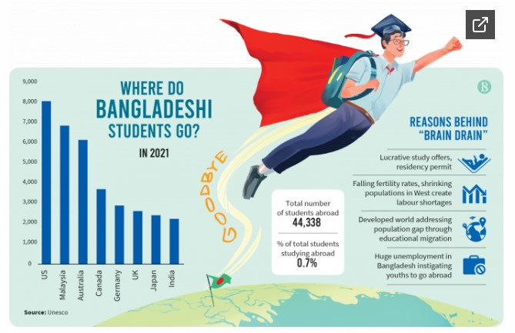

Ultimately that’s a huge loss for the country, and the education should have some revolution to mitigate this problem and expect students from overseas countries to come in Bangladesh for their higher education.

**References:**

* [1] <https://www.quora.com/Why-is-the-Bangladeshi-education-system-so-rubbish>
* [2] <https://www.thedailystar.net/opinion/views/news/why-students-are-unsatisfied-bangladeshi-higher-education-3414056>
* [3] <https://www.tbsnews.net/bangladesh/migration/why-brain-drain-set-rise-403834>